Experiment 9: Implement a Basic Reinforcement Learning Model (Q-Learning)
Aim:
To implement a basic Reinforcement Learning model using the Q-Learning algorithm to learn the optimal path between states based on rewards, and to build a neural network model to predict student results (Pass/Fail) using study hours, attendance, and assignments.
Algorithm:
Part A: Q-Learning
- Import the NumPy library.
- Define the reward matrix R representing the rewards for moving between states.
- Initialize the Q-table with zeros.
- Set the discount factor gamma = 0.8 and the number of training episodes to 1000.
- Randomly select an initial state for each episode.
- Identify the possible actions from the current state using the reward matrix.
- Randomly select a valid action and determine the next state.
- Update the Q-value using the formula:
Q(s, a) = R(s, a) + gamma × max Q(s', a')
- Repeat the process until the goal state (state 5) is reached.
- Display the final Q-table.
Part B: Student Result Prediction Using a Neural Network
- Import the required libraries: Pandas, TensorFlow, and Scikit-learn.
- Load the dataset from data.csv.
- Select Hours_Studied, Attendance, and Assignments as input features.
- Select Result as the target variable and convert Fail and Pass into 0 and 1, respectively.
- Split the dataset into training and testing sets in an 80:20 ratio.
- Apply StandardScaler to standardize the input features.
- Build a neural network with two hidden layers containing 8 and 4 neurons, using ReLU activation, and an output layer with one neuron using sigmoid activation.
- Compile the model using the Adam optimizer, binary cross-entropy loss, and accuracy as the evaluation metric.
- Train the model for 50 epochs, using 20% of the training data for validation.
- Predict student results on the test dataset.
- Convert predicted probabilities into class labels using a threshold of 0.5.
- Calculate and display the classification accuracy.

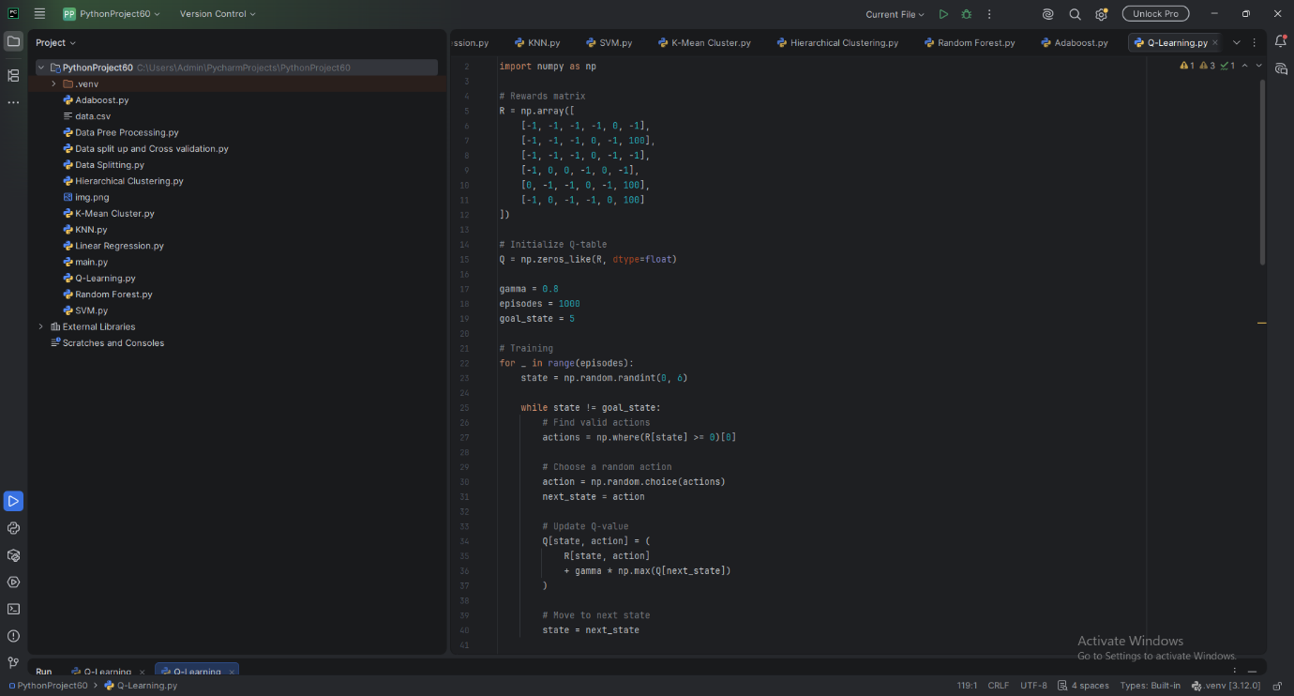

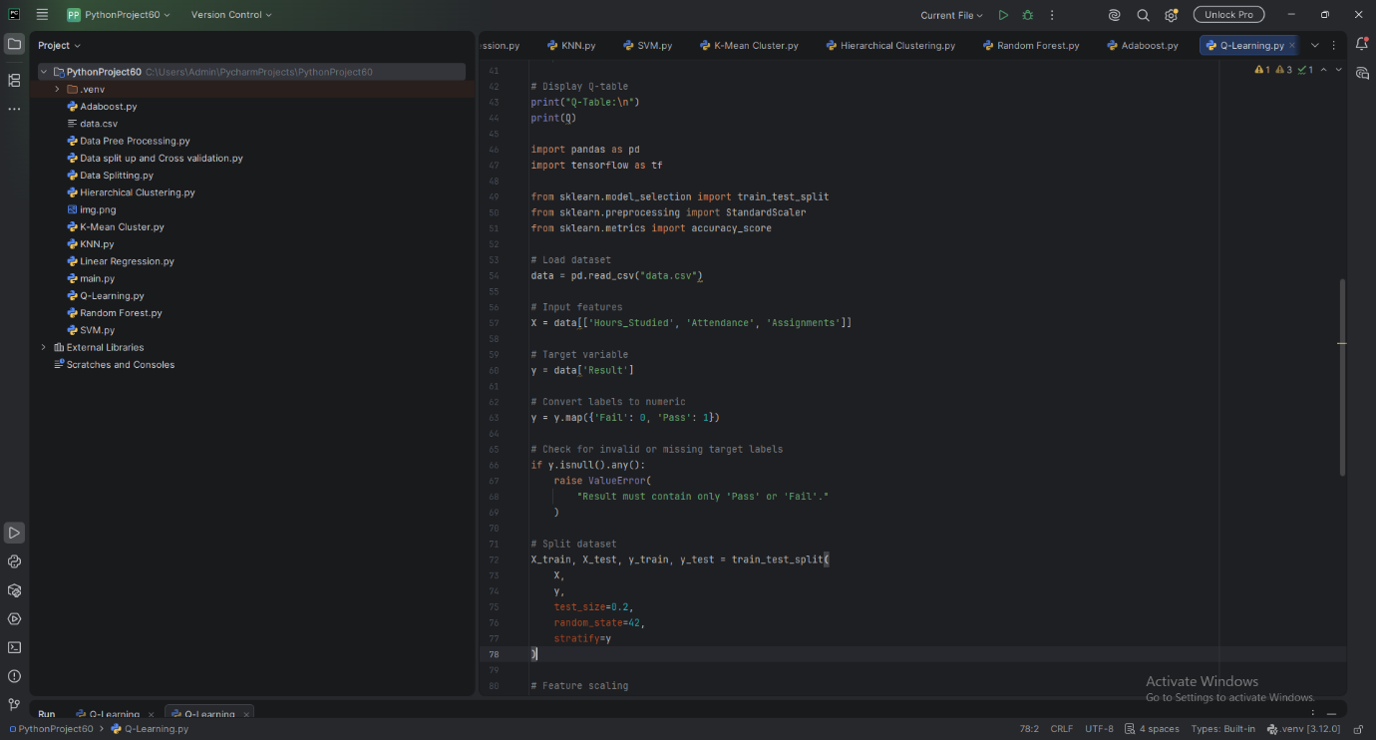
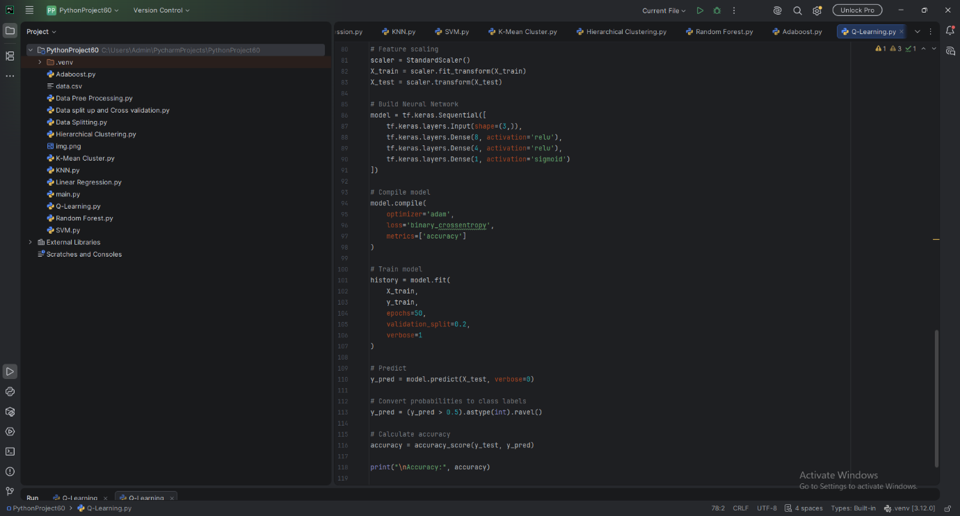

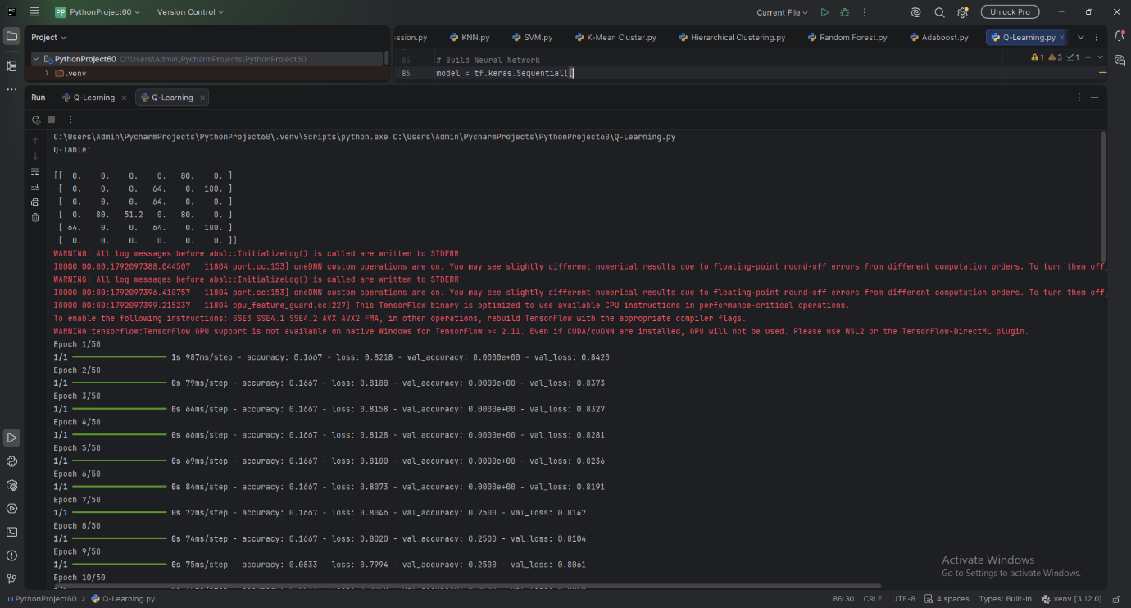
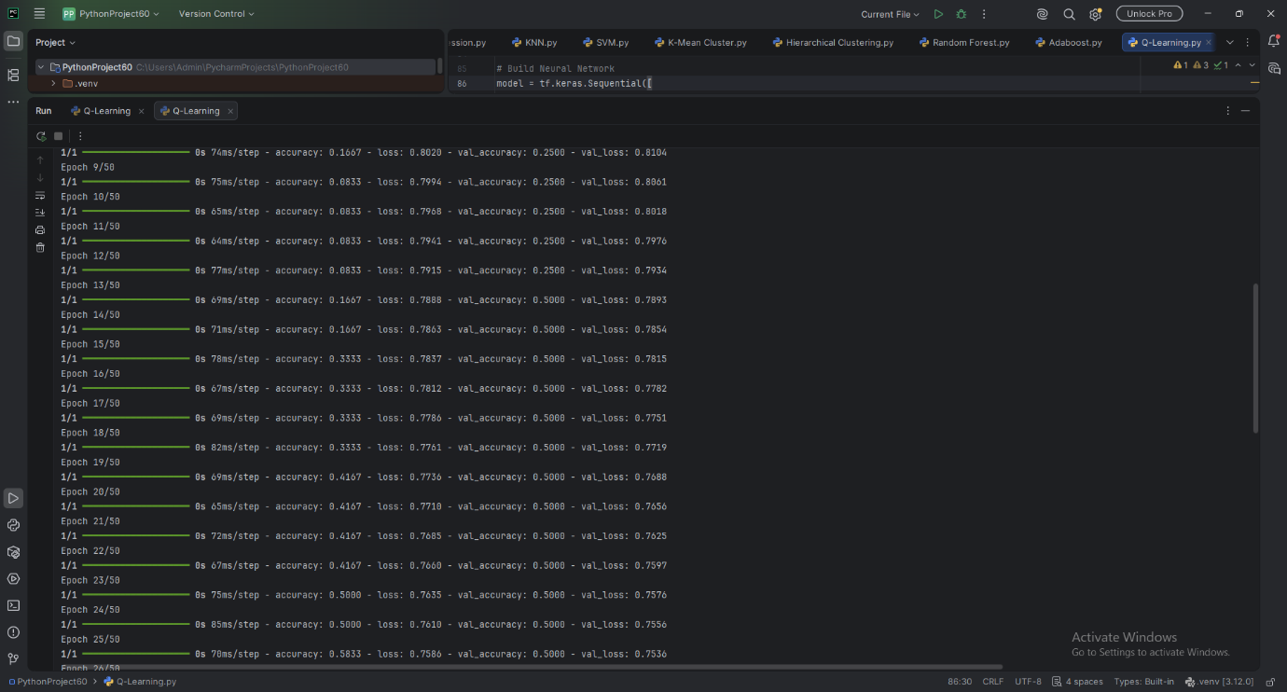

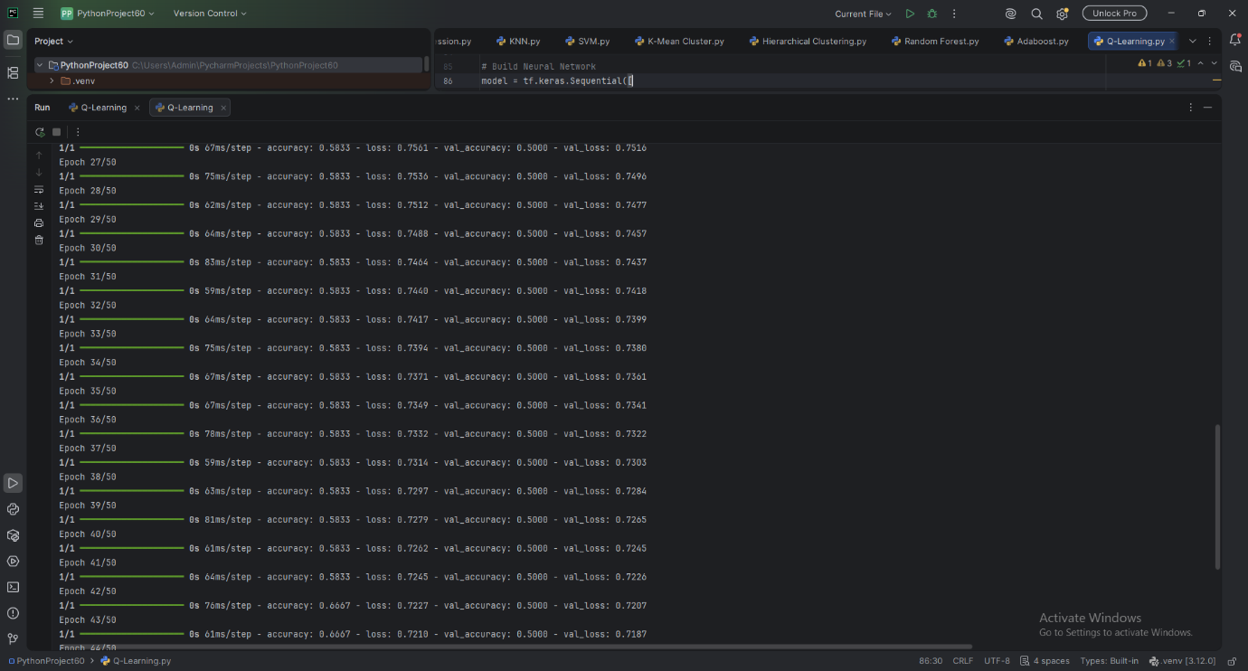
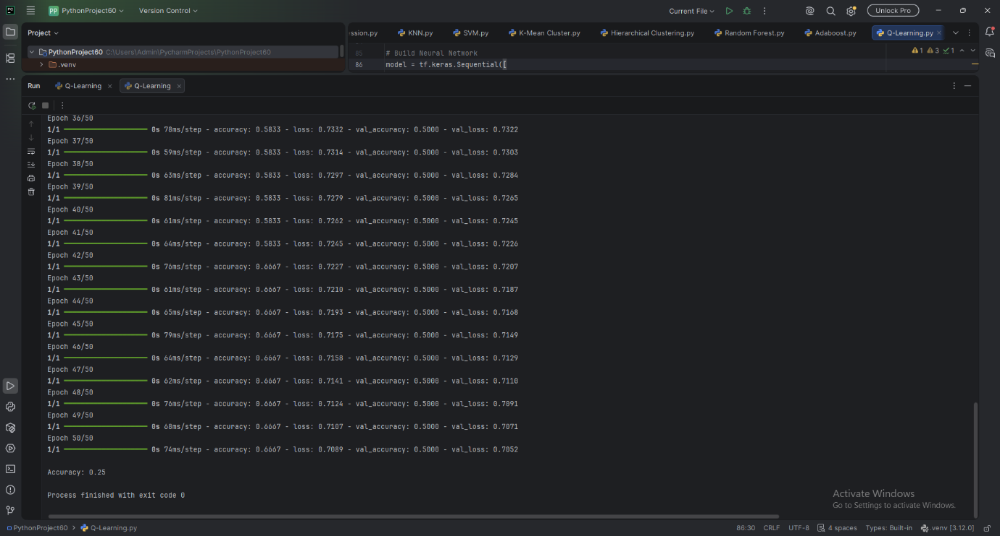

Result:
The Q-Learning model was implemented successfully. The Q-table was updated through repeated training episodes to learn the rewards associated with transitions between states and identify the optimal path toward the goal state (state 5).
The neural network model was trained to predict student results as Pass or Fail based on study hours, attendance, and assignments. The model's performance was evaluated using classification accuracy on the test dataset.
Note: The exact Q-table values and prediction accuracy depend on the training process and the contents of data.csv. The numerical accuracy will be displayed when the code is executed successfully.

